
ST. SIMEON ORTHODOX CHRISTIAN CHURCH
A Mission of the Antiochian Orthodox Christian Archdiocese of North America
Primate- His Eminence Metropolitan SABA, Archbishop of New York and Metropolitan of all North America
28042 Ave. Stanford, Suite D
Santa Clarita, CA 91355
Mailing Address: P.O. Box 800992 Santa Clarita, CA 91380
www.scvorthodox.com

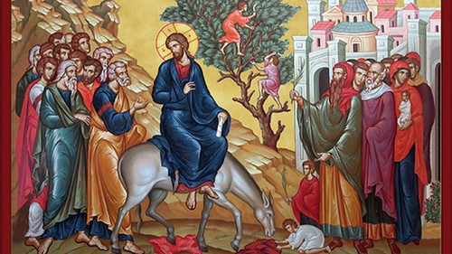
V. Rev. Fr. George Ajalat, Pastor (626) 460-1110 Gajalat@gmail.com

Divine Liturgy Variables for Feast of Palm Sunday:
Entrance of Our Lord Jesus Christ into Jerusalem

**Divine Liturgy of St. John Chrysostom**

WELCOME!
“The Newest Church in Santa Clarita is the Oldest Church in the World.”
St. Simeon Orthodox Church welcomes all of you to our community this Sunday- for truly, “This is the Day that the Lord has made.” We are honored to have you worship with us. If you are new to our community or simply have any questions, please introduce yourselves to Fr. George after the Divine Liturgy. He would love to meet and chat with you. May our Lord bless you and your families.

THE FIRST ANTIPHON
I am filled with joy, for the Lord will hear the voice of my supplication. The anguish of death encompassed me; the perils of hell beset me.

Refrain: Through the intercessions of the Theotokos, O Savior, save us.

I found tribulation and anguish, and I called upon the Name of the Lord. I will walk acceptably before the Lord in the land of the living. (Refrain)

Glory… Both now… (Refrain)

THE SECOND ANTIPHON
I believed, and therefore have I spoken: but I was deeply humiliated. What shall I render unto the Lord, for all His benefits unto me?

Refrain: Save us, O Son of God, Who didst sit upon the foal of an ass, who sing to Thee. Alleluia.

I will take the cup of Salvation, and call upon the Name of the Lord. (Refrain)

I will pay my vows unto the Lord in the presence of all His people. (Refrain)

Glory… Both now… O, only begotten Son and Word of God…

THE THIRD ANTIPHON
O, give thanks unto the Lord, for He is good: for His mercy endureth forever. Let the house of Israel now say that He is good: for His mercy endureth forever. Let the house of Aaron now say that He is good: for His mercy endureth forever. Let all that fear the Lord now say that He is good: for His mercy endureth forever.

- During the Little Entrance, after the verses of the Third Antiphon, chant the Apolytikion of Lazarus Saturday.

THE EISODIKON (ENTRANCE HYMN) OF PALM SUNDAY
Blessed is He Who cometh in the Name of the Lord: God is the Lord and hath appeared unto us. Save us, O Son of God, Who didst sit upon the foal of an ass; who sing to Thee. Alleluia.

APOLYTIKION OF LAZARUS SATURDAY IN TONE ONE
In confirming the common Resurrection, O Christ God, Thou didst raise up Lazarus from the dead before Thy Passion. Wherefore, we also, like the children, bearing the symbols of victory, cry to Thee, the Vanquisher of death: Hosanna in the highest; blessed is He that cometh in the Name of the Lord.

APOLYTIKION OF PALM SUNDAY IN TONE FOUR
As by baptism we were buried with Thee, O Christ our God, so by Thy Resurrection we were deemed worthy of immortal life; and praising Thee, we cry: Hosanna in the highest; blessed is He that cometh in the Name of the Lord.

KONTAKION OF PALM SUNDAY IN TONE SIX
Being borne upon a throne in Heaven, and upon a colt on the earth, O Christ God, Thou didst accept the praise of the angels and the laudation of the children as they cried to Thee: Blessed art Thou Who comest to recall Adam.

THE EPISTLE
Blessed is He Who cometh in the Name of the Lord.
O give thanks unto the Lord, for He is good; for His mercy endures forever.
The Reading from the Epistle of St. Paul to the Philippians. (4:4-9)
Brethren, rejoice in the Lord always; again I will say, Rejoice! Let your forbearance be known to all people. The Lord is at hand. Be anxious for nothing, but in everything by prayer and supplication with thanksgiving let your petitions be made known to God. And the peace of God, which surpasses all understanding, will guard your hearts and your minds in Christ Jesus. Finally, brethren, whatever things are true, whatever things are honorable, whatever things are just, whatever things are pure, whatever things are lovely, whatever things are of good report; if there is any virtue, and if there is any praise, think about these things. The things which you both learned and received, and heard and saw in me, these things do; and the God of peace will be with you.

THE GOSPEL
The Reading from the Holy Gospel according to St. John. (12:1-18)
Six days before the Passover, Jesus came to Bethany, where Lazarus who had died was, whom Jesus had raised from the dead. There they made Him a supper; Martha served, and Lazarus was one of those at table with Him. Mary took a pound of costly ointment of pure nard and anointed the feet of Jesus and wiped His feet with her hair; and the house was filled with the fragrance of the ointment. But Judas Iscariot, Simon’s son, one of His Disciples (he who was to betray Jesus), said, “Why was this ointment not sold for three hundred denarii and given to the poor?” This he said, not because he cared for the poor but because he was a thief, and as he had the moneybox he used to take what was put into it. Jesus said, “Let her alone, let her keep it for the day of My burial. The poor you always have with you, but you do not always have Me.” When the great crowd of the Jews learned that He was there, they came, not only on account of Jesus but also to see Lazarus, whom Jesus had raised from the dead. So the chief priests planned to put Lazarus also to death, because on account of him many of the Jews were going away and believing in Jesus. The next day a great crowd who had come to the feast heard that Jesus was coming to Jerusalem. So they took branches of palm trees and went out to meet him, crying, “Hosanna! Blessed is He Who cometh in the Name of the Lord, the King of Israel!” And Jesus found a young ass and sat upon it; as it is written, “Fear not, daughter of Zion; behold, your king is coming, sitting on an ass’s colt!” His Disciples did not understand this at first; but when Jesus was glorified, then they remembered that this had been written of Him and had been done to Him. The crowd that had been with Jesus when He called Lazarus out of the tomb and raised him from the dead bore witness. The reason why the crowd went to meet Jesus was that they heard He had done this sign.

MEGALYNARION FOR PALM SUNDAY IN TONE FOUR
God is the Lord and hath appeared unto us; ordain a feast, and rejoicing, come let us magnify Christ with palms and branches, crying out with hymns: Blessed is He that cometh in the Name of the Lord, our Savior.

KOINONIKON (COMMUNION HYMN) FOR PALM SUNDAY IN TONE EIGHT
Blessed is He Who cometh in the Name of the Lord. Alleluia.

- During the Communion of the laity, the choir can sing “Rejoice, O Bethany.”

- Post-Communion Hymn: Instead of “We have seen the true light,” sing the Apolytikion of Lazarus Saturday.

THE DISMISSAL
Priest: May He Who accepted to make the foal of a donkey His throne for our salvation, Christ our true God, through the intercessions of His all-immaculate and all-blameless holy Mother; by the might of the Precious and Life-giving Cross; by the protection of the honorable Bodiless Powers of Heaven; at the supplication of the honorable, glorious Prophet, Forerunner and Baptist John; of the holy, glorious and all-laudable apostles; of our father among the saints, John Chrysostom, archbishop of Constantinople, whose Divine Liturgy we have now celebrated; of the holy, glorious and right-victorious Martyrs; of our venerable and God-bearing Fathers; of Saint N., the patron and protector of this holy community; of the holy and righteous ancestors of God, Joachim and Anna, and of all the saints: have mercy on us and save us, forasmuch as He is good and loveth mankind.

Priest: Through the prayers of our holy fathers, Lord Jesus Christ our God, have mercy upon us and save us.

Choir: Amen.
HOLY OBLATIONS
Prayers are offered for Mark and Kouri as they celebrate their 6th Anniversary Today!!! May God grant you many, many more!!! With all of our love, Grayson and the Ajalat, Simon, and Abraham families.

ANNOUNCEMENTS
Make plans to join us on Easter Sunday for our annual “Easter Egg Hunt” following Service! This special event, sponsored by St Simeon Sunday School, is for all children and one that you won’t want to miss! Bring your family and join in the fun!

St. Simeon Charity Outreach is pleased to announce our collaboration with Santa Clarita Veterans Center. They have expressed a need for peanut butter, canned tuna, and canned food goods. Please feel free to speak or call George Sunnaa at (661) 803-0906 or speak with any committee member if you have further questions
Please bring your donations to St. Simeon by May 12, 2024!

Easter special! Buy a Christmas board game and get a free gift (Easter) worth $10-$20 thanks to kind donors. The game can be played anytime of the year. Look for the bundles and help support Sayedna’s dream. All proceeds go to support the children’s special project.

Please submit your oblations to: stsimeonbulletin@gmail.com by 9 p.m. on Wednesday
If you would like to host Coffee Hour please contact Tracy Kuncar at 818-402-7994 or tkuncar@icloud.com
THOUGHT FOR THE WEEK
“Brethren, rejoice in the Lord always; again I will say, Rejoice….The Lord is at hand. Have no anxiety about anything…”
As we gather together on this blessed Sunday, we rejoice with branches of palms and cry Hosanna to our Lord, who “is at hand.” St. Paul’s Epistle for this glorious day speaks to us of the absolute joy of the Christian life. It is a joy that frees us from all anxiety- and from fear of any earthly thing-even death itself. This freedom from fear gives us a peace which passes all human understanding. How can we find this joy?
We must first understand what this joy is not. It is not “happiness” in the usual sense of the word. Most people today are seeking happiness in the success, comfort, and pleasures of this world; to be materially without need, and to be satisfied and content with one’s circumstances and even relationships. The problem with this is that when we base our contentment on external circumstances- those circumstances can, and often do, rapidly shift. Clearly, this kind of happiness can only be fleeting and, at best, superficial. Joy is something much different-deeper, permanent, and unshakeable.
Surprisingly, St. John Chrysostom starts out his commentary on this verse by quoting our Lord Jesus, “Blessed are they that mourn”! How should we understand this? When we mourn the loss of a loved one, we do so because we have had a chance to love them. It is only by loving others that we can truly find joy and blessedness. It is in our loving others that we draw close to God. And as we draw close to God we begin to trust Him. We trust Him, even when we cannot quite understand our external circumstances-whether we are happy or we suffer. We trust Him because He has promised us not a temporal happiness that is fleeting, but rather a joy which is eternal. We can be certain that our love for our departed ones will never end and that it, indeed, will grow stronger and more glorious both in this age and in the age to come. We miss them-for we have lost them temporally- but yet we rejoice as we commend them into the hands of our gracious Lord, looking confidently for our own and their eternal salvation.
Finally, beloved, we must understand that to mourn, at a deeper level, means to mourn for our own sins, and also, even the sins of others. First we must weep for our own sins, for in sinning we have turned our face away from our God. To sin, ultimately, is to seek to find happiness outside of God; on our own- in what we desire. And we must also understand that our God is love- true love. Therefore, when we sin, we transgress against love itself. If we recognize this deep tragedy that lies inside of us and of others, it will be impossible for us to judge others, nor to even judge ourselves. We will only be able to turn to God with tears and say “Lord, be merciful to me a sinner.” This cry is not only one of repentance and mourning, but of trust, of love, and, indeed, of joy. We can have complete confidence that our Lord will never reject such a prayer. From such a prayer comes forth a fervent desire to seek and build in our souls truth, justice, purity, and all of those virtues that St. Paul mentions in this Epistle. If we sincerely strive for these things in our love for Him, He will grant them all to us- and more. We will become thankful-both in good times and in bad. We will rejoice always, for He will fill us with His unending life, and thereby grant us a joy, both here and in the world to come. This is the joy that we Christians should seek every minute of our lives and with every ounce of our strength. It is a joy which can never nor will ever be taken away from us. Amen.
LORD, NOW LETTEST THOU THY SERVANT DEPART IN PEACE, ACCORDING TO THY WORD
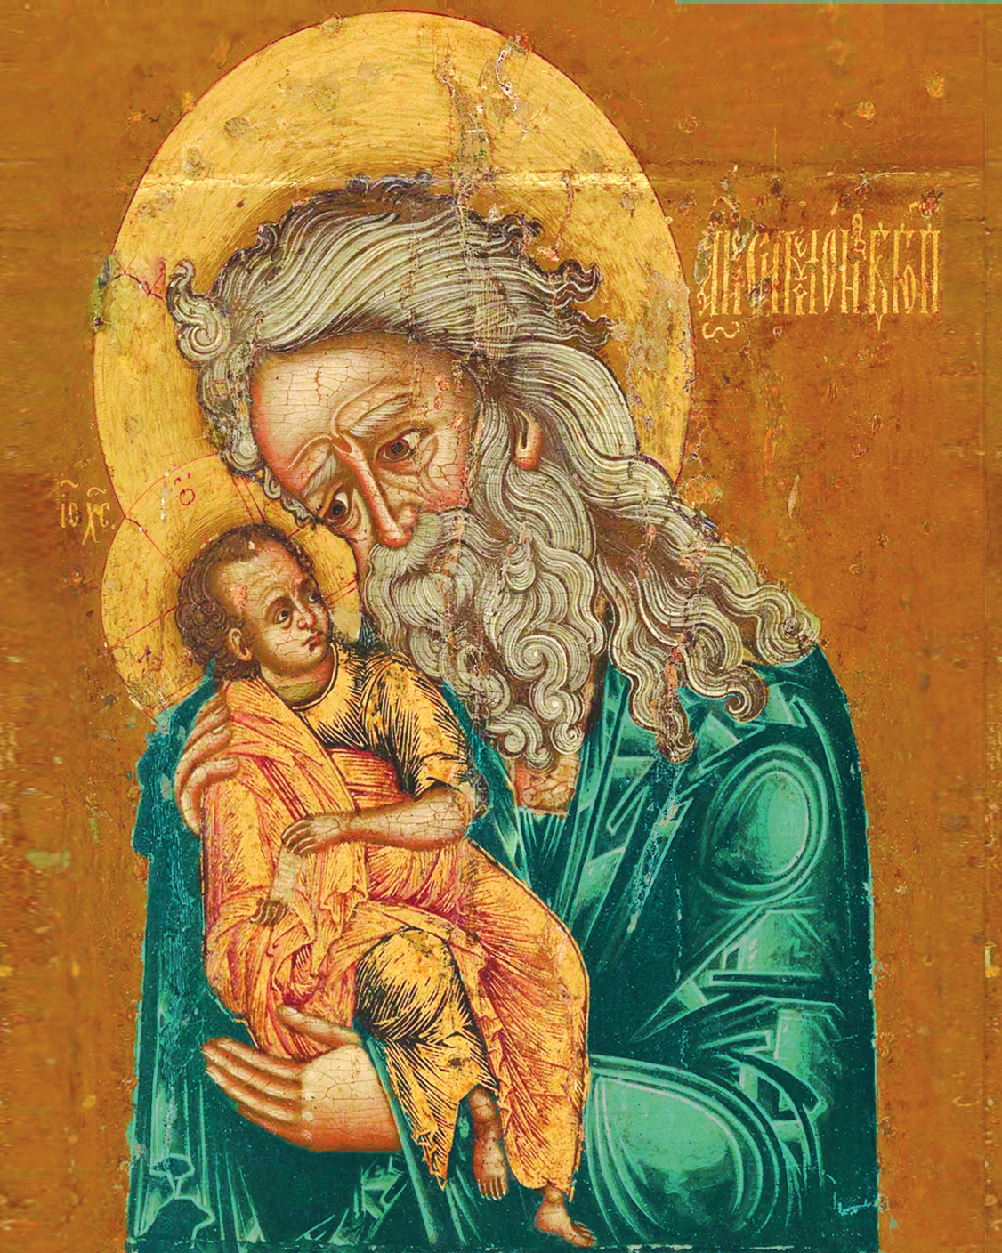

FOR MINE EYES HAVE SEEN THY SALVATION

